./

GENESIS - Mini-project



|  |  |  |  |  |  |
| --- | --- | --- | --- | --- | --- |
| **Ver. Rel. No.** | **Release Date** | **Prepared. By** | **Reviewed By** | **To be Approved** | **Remarks/Revision Details** |
| 1 | 07/12/2020 | Amaljith |  |  |  |
| 2 | 07/12/2020 | Anoosha Clarance |  |  |  |
| 3 | 07/12/2020 | Toti Shoba Rani |  |  |  |
|  |  |  |  |  |  |
|  |  |  |  |  |  |

**Details**

Contents

Contents 3

1.INTRODUCTION 4

2.REQUIREMENTS 4

2.1.AGEING: 4

2.2.COSTING: 5

2.3. WWWWH 6

2.4. MY REQUIREMENTS 6

2.4.1 HIGH LEVEL REQUIREMENTS 6

2.4.2. LOW LEVEL REQURIMENTS 7

3.SWOT ANALYSIS 8

4.DESIGN 9

4.1.UML DIAGRAM 9

4.2. Activity Diagram 10

4.3.Use Case Diagram 10

4.4.Sequence Diagram 11

5. TEST PLAN 11

5.1.High level and Low level Test plan 11

6.GITHUB DASHBOARD 13

7.GITHUB LINK 13

REFERENCES 13

**List of figures**

Figure 1:Aging 5

Figure 2:Costing 6

Figure 3: UML diagram1 9

Figure 4: UML diagram1 9

Figure 5: Activity diagram 10

Figure 6: Use Case Diagram 10

Figure 7: Sequence diagram 11

CALCULATOR

# 1.INTRODUCTION

 A Calculator is a small (often pocket sized),usually inexpensive electronic device used to perform the basic arithmetic operations , trigonometric functions, prime etc. It can also programed and used as a software in electronic devices like mobile, laptops, PC etc. Here were going to make a software that implements basic arithmetic operations, trigonometric and some other functions.

# 2.REQUIREMENTS

## 2.1.AGEING:

* The first scientific calculator that included all of the basic ideas above was the programmable Hewlett-Packard HP-9100A released in 1968.
* The HP-35, introduced on February 1, 1972, was Hewlett-Packard's first pocket calculator and the world's first handheld scientific calculator.
* Handheld scientific calculator on January 15, 1974, in the form of the SR-50.
* The first graphics calculator was developed in 1990 Tl-81 for math education that adds a new visual dimension to mathematics instruction.

Figure :Aging

## 2.2.COSTING:

The costing of these apps is mostly free to use, but to use some additional functionalities like bill book addition keep track of accounts, which will be the monetizing. factor

Figure :Costing

## 2.3. WWWWH

* **What -** A calculator is a device used for the mathematical calculation, which makes work much easier.
* **When -**When the calculations to be made are complicated and take more time.
* **Where -** Itis used where the calculations are complex
* **Why -** A calculator saves human power and provides accurate results.
* **How -** Calculators are made depending on requirement. Different types of calculators are available such as simple calculator, scientific, graphical and printing calculators.

## 

## 2.4. MY REQUIREMENTS

### 2.4.1 HIGH LEVEL REQUIREMENTS

|  |  |
| --- | --- |
| **ID** | **Description** |
| **HL_01** | To display the menu. |
| **HL_02** | To choose an option from the menu. The options are:   * 1. Arithmetic: To perform arithmetic operations.   2. Trigonometric: To perform trigonometric operations.   3. Other options: performing other mathematical operations.   4. Exit: to exit from the menu |
| **HL_03** | To choose an option from the Arithmetic operation menu. The options are:   * 1. Addition   2. Subtraction   3. Multiplication   4. Division   5. Factorial   6. Squareroot   7. Exit |
| **HL_03** | To choose an option from the trignometric operations menu. The options are:   * 1. Sine   2. Cosine   3. Tangent   4. Cosec   5. Sec   6. Cot   7. Exit |
| **HL_04** | To display the result accurately. |

### 2.4.2. LOW LEVEL REQURIMENTS

|  |  |  |
| --- | --- | --- |
| **ID** | **REQURIMENTS** | **DESCRIPTION** |
| **LL_01 LL_02 LL_03 LL_04** | add() sub()  multiply()  divide() | Perform addition  Perform subtraction  Perform multiplication  Peform division |
| **LL_05**  **LL_06**  **LL_07**  **LL_08**  **LL_09**  **LL_10** | Sine()  Cosine()  Tan()  Cosec()  Sec()  Cot() | Perform various trigonometric operations |
| **LL-11** | factorial() | Find factorial of a number |
| **LL_12** | isarmstrong() | Find whether a number is Armstrong or not |
| **LL-13** | isprime() | Find whether a number is prime or not |
| **LL_14** | Squareroot() | Find square root of a number |

# 3.SWOT ANALYSIS

# 4.DESIGN

## 4.1.UML DIAGRAM

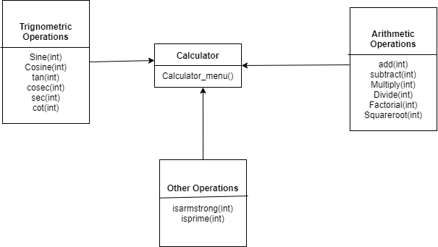

Figure : UML diagram1

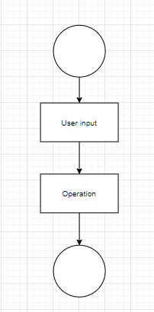

Figure : UML diagram1

## 

## 4.2. Activity Diagram

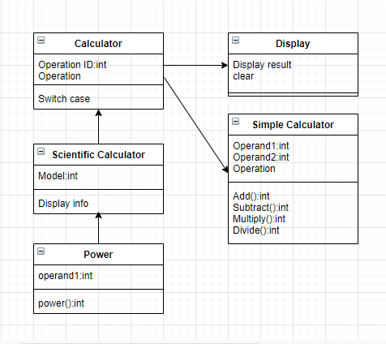

Figure : Activity diagram

## 4.3.Use Case Diagram

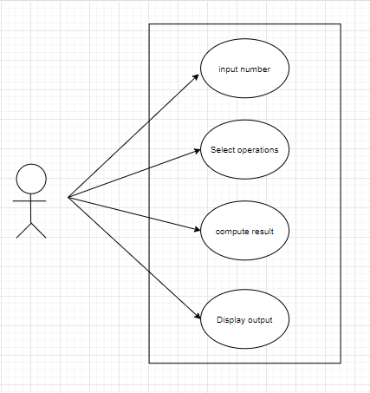

Figure : Use Case Diagram

## 4.4.Sequence Diagram

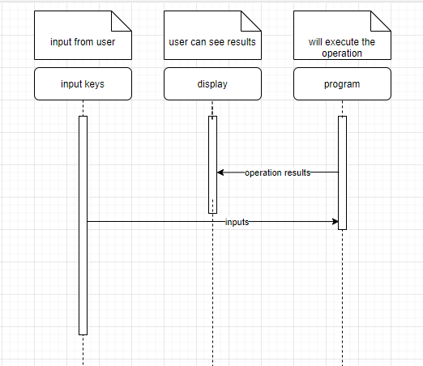

Figure : Sequence diagram

# 5. TEST PLAN

## 5.1.High level and Low level Test plan

|  |  |  |  |  |  |
| --- | --- | --- | --- | --- | --- |
| **ID** | **Description** | **Precondition** | **Expected I/P** | **Expected O/P** | **Actual O/P** |
| H_01_L_01 | Input1 operand | add/subtract/multiply/divide/factorial/squareroot are chosen | Input 1 operand only | Enter 1 operand | Enter 1 operand |
| H_01_L_02 | Input2 operand | Sine/cosine/tangent/cosec/sec/cot are chosen | Input 2 operand only | Enter 2 operand | Enter 2 operand |
| H_01_L03 | Input3  Operand | Prime/armstrong/ are chosen | Input3  Operand only | Enter3  operand | Enter3  operand |
| H_02 | Perform arithmetic operations | Add/subtract/division/multiplication/factorial chosen | Input operands | Correct result obtained | Correct result obtained |
| H_02_L_01 | Perform add | Chosen add and input 2 operand | 10,20 | 30 | 30 |
| H_02_L_02 | Perform add | Chosen add and input 2 operand | 750,7500 | 8250 | 1500 |
| H_02_L_03 | Perform subtraction | Chosen subtract and input 2 operand | 0,3 | -3 | -3 |
| H_02_L_04 | Perform subtraction | Chosen subtract and input 2 operand | 1000,900 | 100 | 1 |
| H_02_L_05 | Multiply | Chosen Multiply and input 2 operand | 1,0 | 0 | 0 |
| H_02_L_06 | Multiply | Chosen Multiply and 2 operand | 2,5 | 10 | 2 |
| H_02_L_07 | Divide | Chosen divide and 2 operand | 1,0 | Undefined | 0 |
| H_02_L_08 | Divide | Chosen divide and 2 operand | 2,2 | 1 | 3 |
| H_02_L_08 | Factorial | Chosen factorial and 1 operand | 5 | 120 | 120 |
| H_03 | Perform check operations | Prime/armstrong/even check chosen | Input operand | Correct result obtained | Correct result obtained |
| H_03_L_01 | Prime check | Chosen prime and 1 operand | 7 | 0 | 0 |
| H_03_L_02 | Armsgstrom check | Chosen Armstrong and 1 operand | 153 | 1 | 1 |
| H_04_L_01 | Sine function | Chosen sine and 1 operand | 90 | 1 | 1 |
| H_04_L_02 | Cosine function | Chosen cosine and 1 operand | 45 | 0.707107 | 0.707107 |
| H_04_L_03 | Tangent function | Chosen tan and 1 operand | 45 | 1 | 1 |
| H_04_L_04 | Cosec function | Chosen cosec and 1 operand | 45 | 1.414214 | 1.414214 |
| H_04_L_05 | Sec function | Chosen sec and 1 operand | 0 | 1 | 1 |
| H_04_L_06 | Cot function | Chosen cot and 1 operand | 90 | 0 | 0 |

# 6.GITHUB DASHBOARD

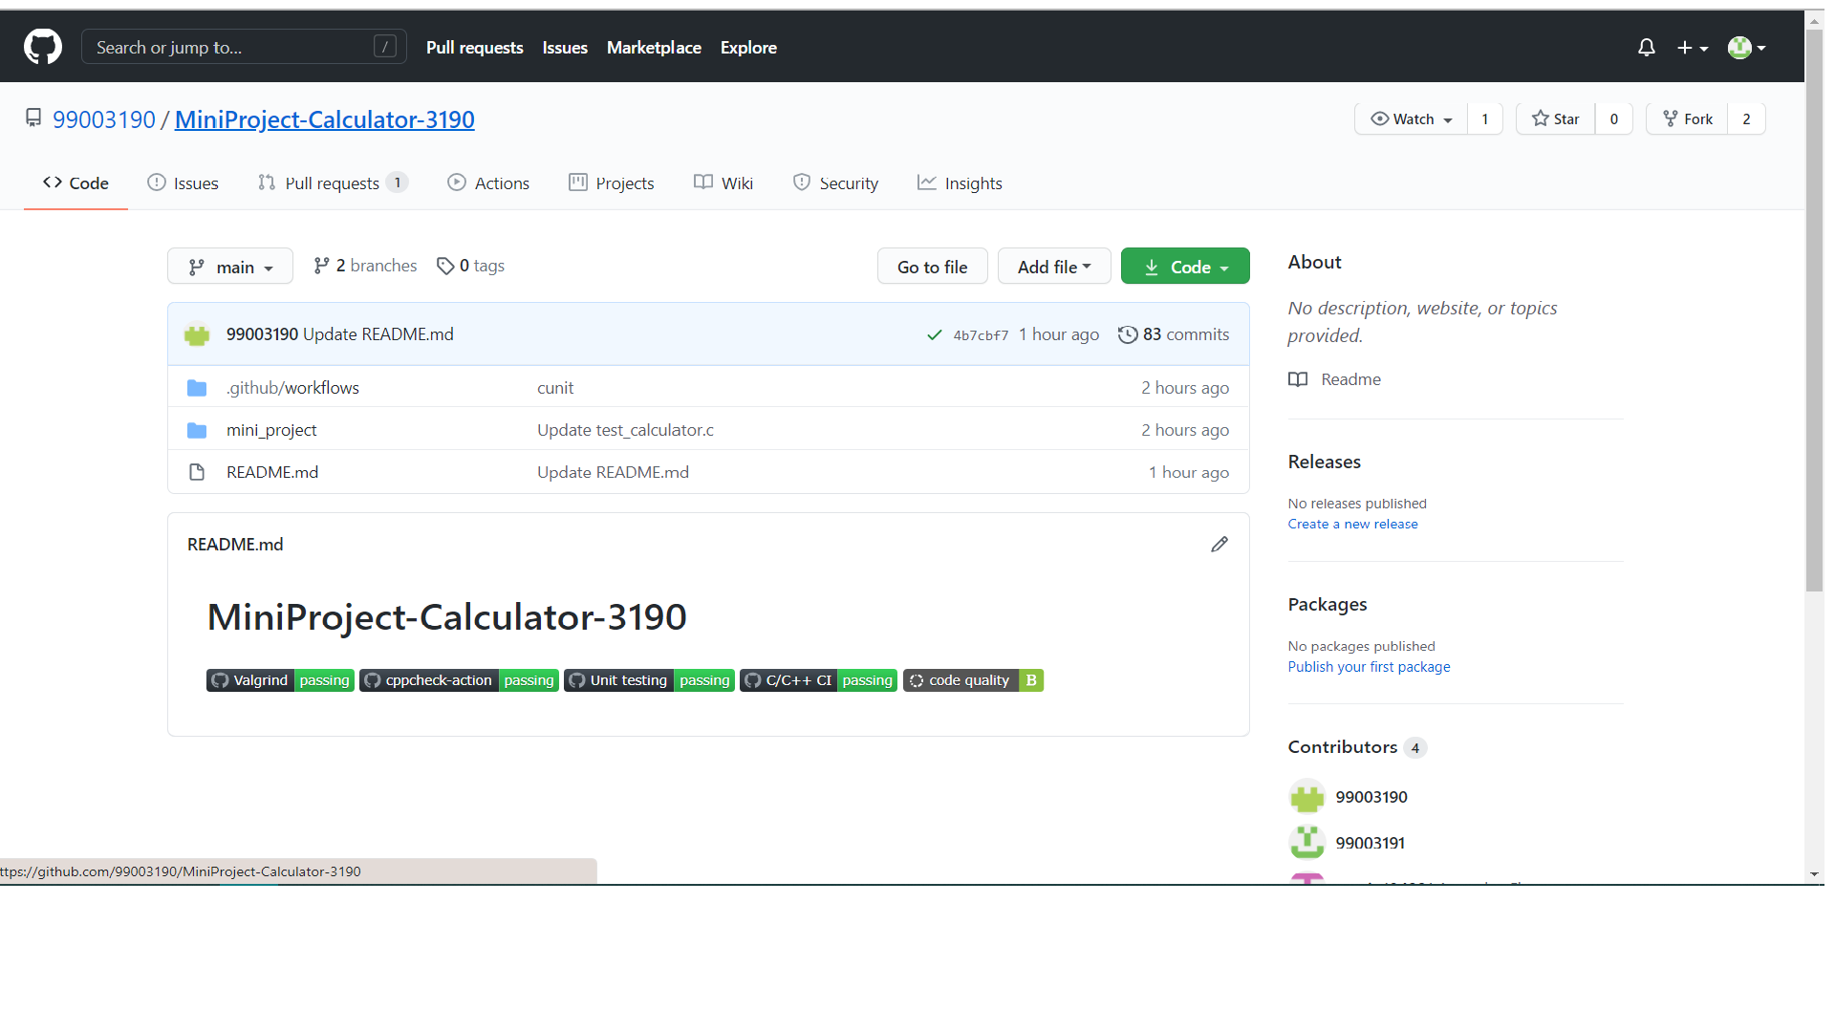

# 7.GITHUB LINK

[**https://github.com/99003190/MiniProject-Calculator-3190**](https://github.com/99003190/MiniProject-Calculator-3190)

# REFERENCES

[**https://fresh2refresh.com/c-programming/c-programs/c-code-for-calculator-application/**](https://fresh2refresh.com/c-programming/c-programs/c-code-for-calculator-application/)